Lab 10
Using notifications to trigger aws lambda Lab:
Screenshot of part 38:

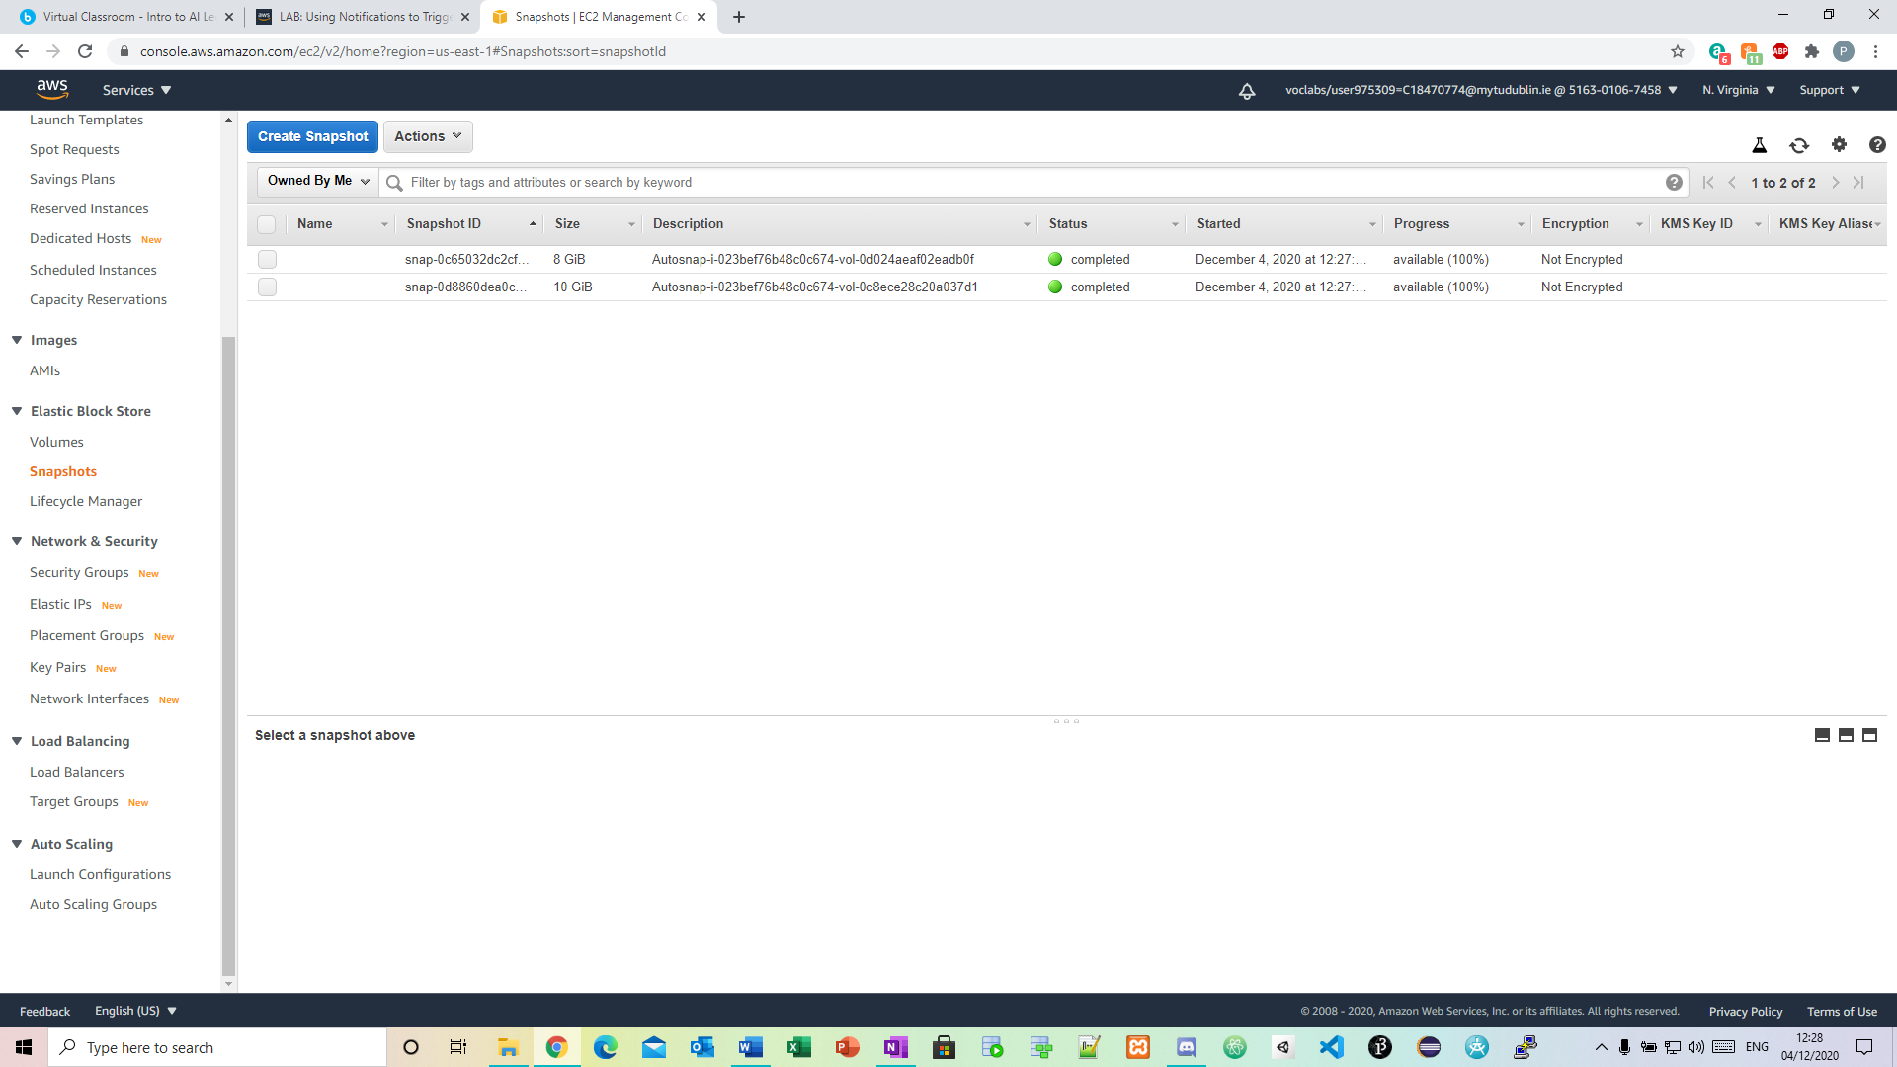

Automating infrastructure deployment with aws Lab:
Screenshot of part 12:

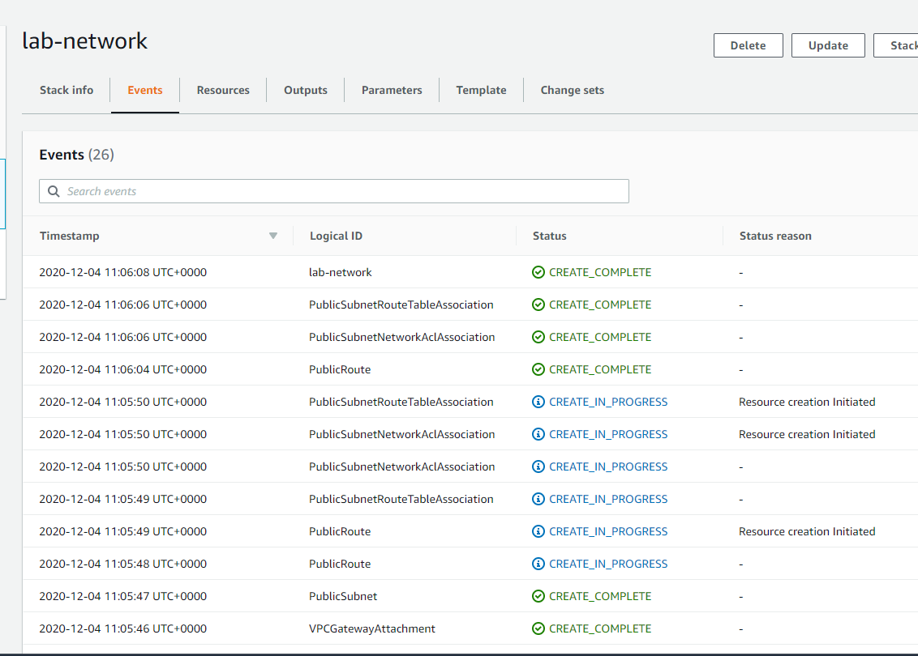
Screenshot of part 20:

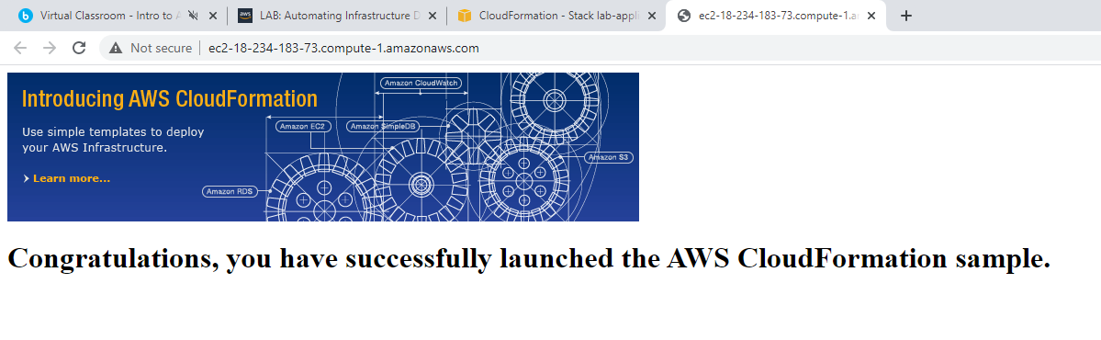

Screenshot of part 35:

